4K Cryosystem Quick Health Check
Wahlquist Revision 9, 4/26/2013
Rev 9 Release Highlight:
- Section 6: Modified the instructions for performing the excel computation of average power because of observed differences in the way the instruction behaved in broad use.
- Appendix A added to provide basic excel instruction
Rev 8 Release Highlights:
- REQUIRED FIELD SERVICE ENGINEER DOCUMENTATION: Add Stand alone or LCC as system identifiers.
- Section 1: Modified to identify and add 4K systems originally supplied without LCC and provide test path. (It is the intent of the document to infer correct temperature and flow exists if the “Average Power” determined in section 6.c is within specification.)
- Section 4: Modified to reflect that original LCC cabinets cannot report flow and remove it from the flowchart (It is the intent of the document to infer correct flow exists if the “Average Power” determined in section 6.c is within specification.)
- Section 5: The Flow chart modified to allow determination of flow, if possible, when the procedure is not being performed remotely.
Purpose:
This document is intended to serve as a guide to determining if the MR system 4K Cryosystem is functioning at the required level of performance.
For systems reachable via RSN, the process can be completed remotely because the cryocompressor charge check can be deferred if all other checks pass.
It is anticipated that the “first pass” through this procedure can be completed remotely in less than .5 hour by a trained MR FSE. After the initial effort, succeeding evaluations are expected to require less than 10 minutes per system.
The MR Cryo system is comprised of the following sub systems:
Chiller or Facility chilled water source.
Cryo Compressor
Cold Head
Structure of the Health Check:
This document provides a series of Pass or Fail functional checks that, individually, identify required function. The failure of any sub system is a critical failure.
Failure of the system to meet any individual requirement identifies a system that requires remedial action.
Temperature and Flow requirements for the Cryo Compressor are identified within the LCC specifications. By definition, a system that fails the primary water and flow requirements of the LCC fails the requirements of the cryocompressor.
Note: Temperature stability, as defined by the LCC specifications, is not a component of this process. Short term temperature fluctuation of greater than 2C over a 10 minute period should be resolved if they are identified.
For Convenience, the following conversion factors are provided:
1 Gallon = 3.78541178 Liters
1 Liter = 0.264172052637296 Gallons
C = 5/9 (F-32)
F = 9/5 (C+32)

Overview of Functional checks and criteria:
- Primary water temperature set point is required to be within specification.
If remedial repair is required, the following criteria should be used for all repairs:
  - Required to be within +- 1C of “optimal” 12C set point for systems with Philips provided Chiller service.
  - Required to be within specification identified in sections 3 and 5 for Facility maintained primary coolant.

- Primary flow.
  - Required to be both within +- 1C of “optimal” 12C set point for systems with Philips provided Chiller service and within the flow specifications identified in sections 3 and 5.
  - Required to be within flow specification identified in sections 3 and 5 for Facility maintained primary coolant temperature and flow.

- Compressor Helium charge.
  - Required to meet published standard in the cryo compressor SPD.

- Cold head efficiency
  - Measured as Cryosystem margin.
  - Cannot be determined if any other criteria fails.

REQUIRED FIELD SERVICE ENGINEER DOCUMENTATION
- Record the data as you make the checks identified in this document.
- If the system fails to meet the criteria, keep the Service Work order open until all repairs have been completed.
- Retest the system after any repairs and record the following information in the closing notes of the Service Work Order.
  - Identify “Stand Alone”, “LCC”, “LCC2”, or “LCC2A”: ________
  - Primary Temperature of Primary Water (Sec 3 or 5): ________
  - Flow in Liters / Minute of the Primary flow (Sec 3 or 5): ________
  - Record the computed Margin (Sec 6): ________
  - Record Cryo Compressor charge (if performed) (Sec 7): ________
Quick Health Check
- Determine the Cryosystem coolant type, Stand Alone or LCC, and perform LCC overview via RSN or on Site inspection when possible.
(The LCC overview test is described in the Ingenia PM manual)

Go to step 2 for LCC2/LCC2A or step 4 for LCC.

- Initial evaluation of flow and temperature for LCC2 and LCC2A.

Go to step 3.
- LCC2 and LCC2A Final Evaluation of Temperature and Flow.
Note: This section requires that the Field Service Engineer know the composition of the Primary coolant. The chiller service company or the customer should be able to provide this information.

Go to section 6.

- Initial evaluation of flow and temperature for LCC.
Go to step 5.

- LCC Final Evaluation of Temperature and Flow.

Go to step 6.
- Cold head efficiency
In this section cold head efficiency will be assessed by identifying the “Margin” of the system.
(Margin can be most easily understood as a measure of the heat energy required to maintain pressure in the magnet at 30mB. The more efficient the coldhead, the more energy required to build gas pressure.)
The current minimum requirement for margin is:
Stable margin above 100mW for two days, no downward trend.
a. Measurement to be made over a normal two day (48 hour) period of scanning operation.
b. Data to be used is the “average” column of the RMMU logs, not the STT.
c. Occasional excursions to “zero” margin that coincide with more intense scans are allowed.

Procedure:
- In Field Service Framework, go to System Adjustment/Test and Tuning procedures/Magnet/”Dump RMMU/MEU logfile”.
- Copy the “dumped” rmmu log file and paste it into an excel spread sheet.
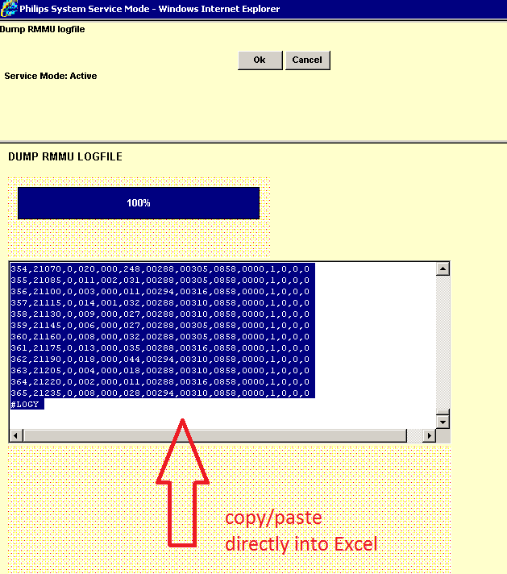
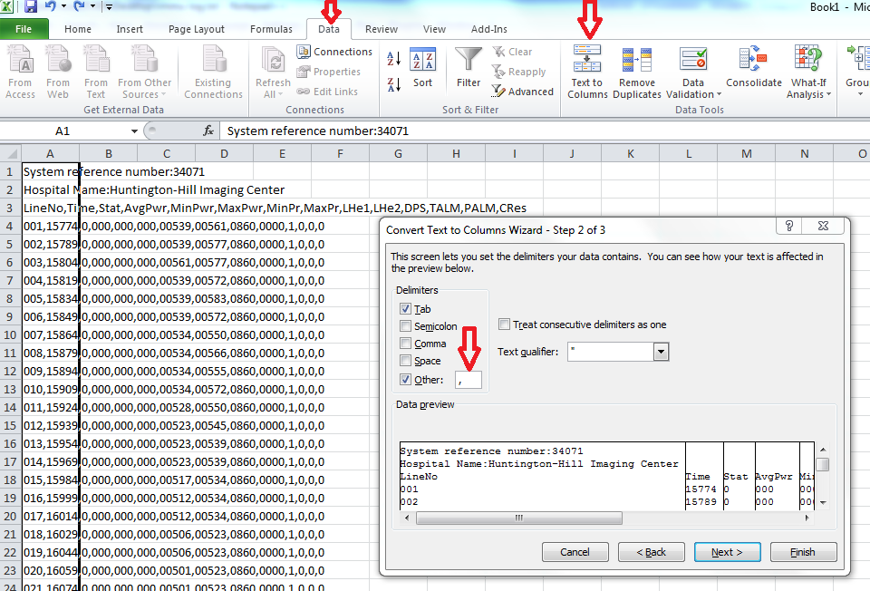

- Determine the “Average mW” of the “AvgPwr” column.
The basic method for determining average power is to:
- Add all of the “AvgPwr” values in column “D”.
- Divide the result by 365 (the number of data lines) to determine the average,
- Multiply the result by 10 to determine the real Average Power in mW.
Notes: if you are working from either the “rmmu dump” from Field Service Framework diagnostics or a “rmmuxxxxxxx.txt” file from a FTP download, the values of the AvgPwr, MinPwr, and MaxPwr are 1/10 the real value and must be converted to provide a true power value.
The following Instruction will usually work. If it does not, see Appendix A for more comprehensive instruction.
Formula:
If the excel spread sheet if created without extra lines between the data lines, you should be able to use the formula =SUM(((D4:D368)/365)*10), as shown below.
Note: If the spread sheet inserts extra lines, you will have to modify the formula to insure that the range of cells being averaged starts at the first data line and ends at the last data line.
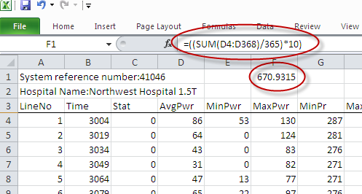
- RECORD THE AVERAGE POWER: ___________

Go to step 7.
- Compressor Helium charge.
If you are on site, this section must be completed.
If you are evaluating the system remotely and all of the minimum specifications for all previous sections have been met, the evaluation of this section can be deferred.
- Maintenance of the correct Helium pressure in the Cryo Compressor is a key element in maintaining cryo system performance.

The correct charge for your system is available from the SPD, the most recent information, as of 4/4/2013 is:
Normal compressor pressures:
Type | Static (off) | Dynamic (on)
HC8E1 | 275-280 | Supply: 310 - 340 PSI Return: 110-140 PSI
CSW-71 (4K) | 1.60-1.65
CSW-71 (10K) | 1.45-1.50
F50 | 1.60-1.65 | H 1.9 - 2.2 L 0.4 - 0.6 MPa

Note: The Static pressures are specs, the dynamic numbers are just for reference, they are approximate numbers and not specs.

- Correct water flow is a primary requirement and must be met. In the preceding sections the primary water flow and temperature were determined as a “system” requirement. If there is any failure of the system to meet the system requirement, the specific requirement for the Cryo Compressor must be identified and corrected if it is insufficient.

The specific requirement for your system can be found in the preventive maintenance manual and the cryocompressor SPD.

As an example, the Ingenia requirement from the PM Manual is:
Check that the water flow ≥7 liter/minute (≥1.85 gallon/min). If the water flow is out of spec, check the LCCII main flow (For details see the SPD). If the main flow is also within spec, then most likely the flow is restricted by the compressor. In that case the compressor must be flushed.

Appendix A: Using Excel to determine the Average Power.
- Left click into an empty cell.
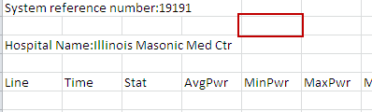
- Select “Formulas/ auto sum / Average. You will see the formula populate the chosen cell with a blinking cursor.
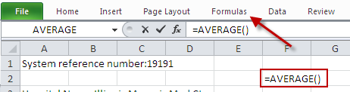
- With the cursor blinking in the formula, left click into the first data cell. You will see the location of that cell populate the formula.
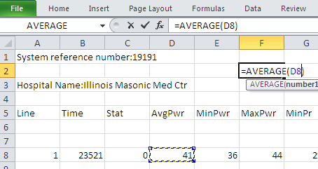
- Hold down on the “shift key and go to the last data cell. Click into the cell. You will see the chosen cell populate the formula. Your formula should now look similar to the example.
- 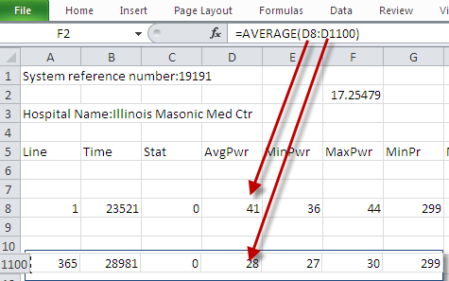
- The formula will return the “Average” of the values in column D.
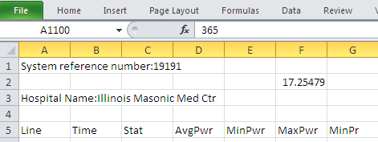
- Multiply this value by 10 to obtain the average power in mW. This can be done by moving the decimal point one place to the right. In the example above, the raw value of 17.25479 becomes 172.5479 mW.

